Math Reviewer
Cartesian Coordinate System
Cartesian Coordinate System:
- Cartesian Coordinate System – A grid-based framework used to uniquely identify the position of points in a space using numerical coordinates invented by French mathematician and philosopher René Descartes, it translates geometric shapes into algebraic equations, serving as the foundation for analytic geometry.
- Ordered Pair (Coordinates) – A pair of numbers that is used to represent a point on a Cartesian plane whereas. The X coordinate is Abscissa, and the Ordinate is the Y axis.
$$(x,y)$$
- Axis – Is a line of reference with coordinates$(0, 0)$.
- Origin – Is a point of reference with coordinates $(0, 0)$, it helps locate a point on the coordinate plane.
Cartesian Plane:  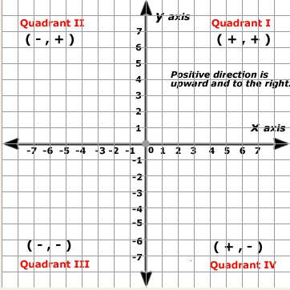 | Example of Coordinates:  - (3, 4)  - (-1, 6)  - (7, -5)  - (-5, -4)  Other Information:  - “0 is on x axis” – Refers to any point where the y-coordinate is 0, like (x, 0). So, points like (1, 0), (-3, 0), etc., are on the x-axis.  - “0 is on y axis” – Refers to any point where the x-coordinate is 0, like (0, y). So, points like (0, 2), (0, -5), etc., are on the y-axis.

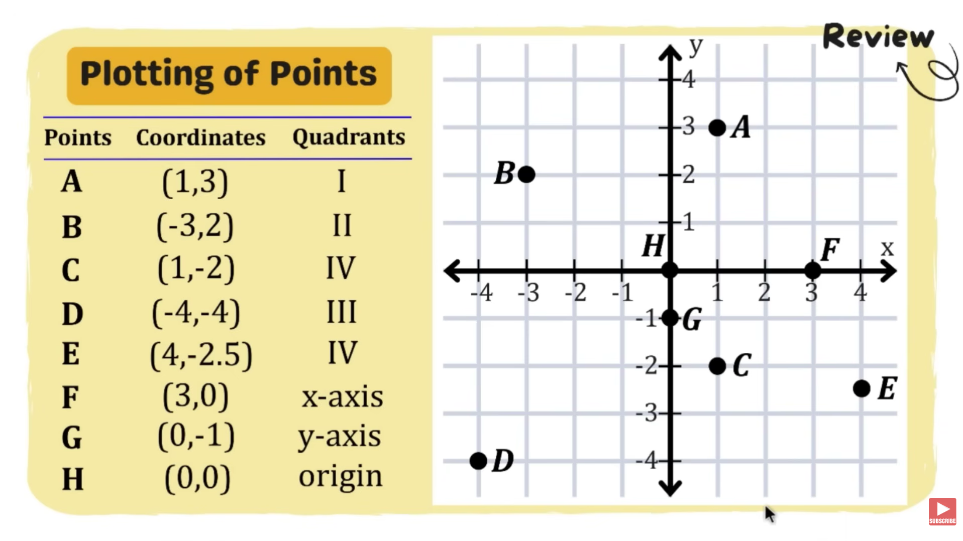
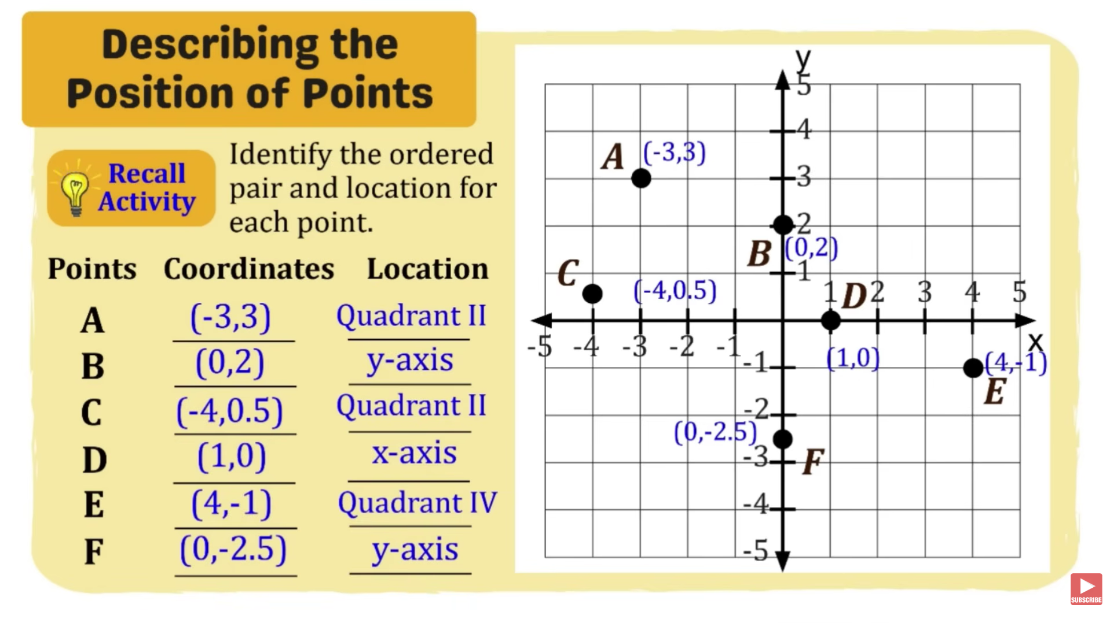

Transformations:
- Transformation – A change in the position, size, or orientation of a figure on a coordinate plane while preserving or altering its shape, depending on the type of transformation. Common transformations include translation, reflection, rotation, and dilation. The original image is called the preimage, and the transformed figure is called the image.
- Translation – A transformation that slides a figure from one position to another without changing its size, shape, or orientation. Every point moves the same distance and in the same direction. Going to the right and top is positive, going to the left and the bottom is negative.
$$\left(x,y\right)=(x±a,y±b)=$$

- Reflection – A transformation that flips a figure across a line of reflection, producing a mirror image. The reflected figure has the same size and shape but the opposite orientation.
Line of Symmetry: | Transformation Formula: | Example:
Across the x-axis $(y=0)$ | $$(x,y)→(x,-y)$$ | $$(3,5)→(3,-5)$$
Across the y-axis $(x=0)$ | $$(x,y)→(-x,y)$$ | $$(3,5)→(-3,5)$$
Across the origin | $$(x,y)→(-x,-y)$$ | $$(3,5)→(-3,-5)$$
Across the line $y=x$ Diagonal line from the bottom-left to the top-right | $$(x,y)→(y,x)$$ | $$(2,7)→(7,2)$$
Across the line $y=-x$  Diagonal line from the top-left to the bottom-right | $$(x,y)→(-y,-x)$$ | $$(2,7)→(-7,-2)$$

- Rotation – A transformation that turns a figure around a fixed point, called the center of rotation, by a specified angle and direction (clockwise or counterclockwise). The rotated figure maintains the same size and shape, but its orientation and position change depending on the angle of rotation.
Angle: | Counterclockwise (CCW): | Clockwise (CW):
$$90°$$ | $$(x,y)→(-y,x)$$ | $$(x,y)→(y,-x)$$
$$180°$$ | $$(x,y)→(-x,-y)$$ | $$(x,y)→(-x,-y)$$
$$270°$$ | $$(x,y)→(y,-x)$$ | $$(x,y)→(-y,x)$$
$$360°$$ | $$(x,y)→(x,y)$$ | $$(x,y)→(x,y)$$

Quadratic Inequalities
Quadratic Inequalities:
- Quadratic Inequalities – A mathematical statement that compares two linear expressions using an inequality symbol instead of an equal sign. Unlike a linear equation, it has many possible solutions rather than just one. The solution is any value that makes the inequality true.
$$Ax±Bx±C>0$$ | $$Ax±Bx±C≥0$$
$$Ax±Bx±C<0$$ | $$Ax±Bx±C≤0$$
Where $A, B and C$ are real numbers, and $a≠ 0$ and $b≠ 0$

Solving Quadratic Inequalities in One Variable:
Symbol | Meaning | Boundary Included? | Number Line Symbol
< | Less than | No | Open circle (○)
> | Greater than | No | Open circle (○)
≤ | Less than or equal to | Yes | Closed circle (●)
≥ | Greater than or equal to | Yes | Closed circle (●)

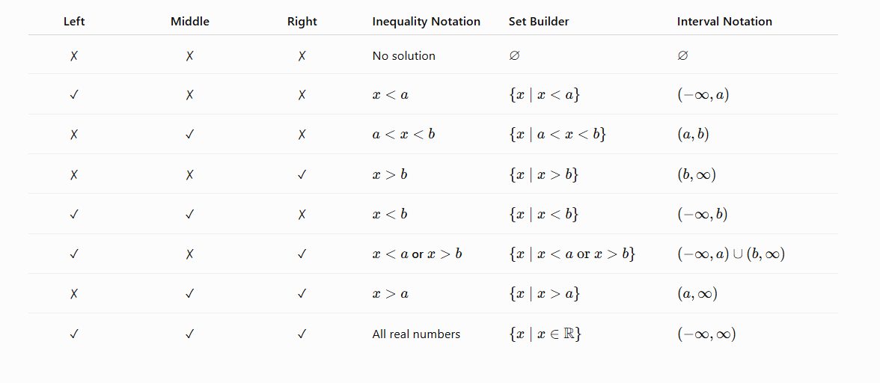

Example 1:
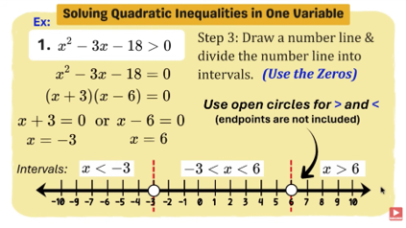 | 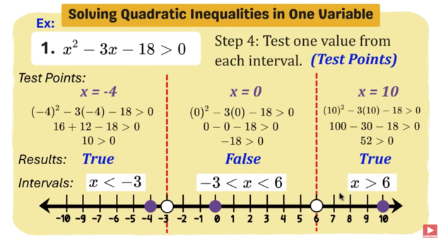
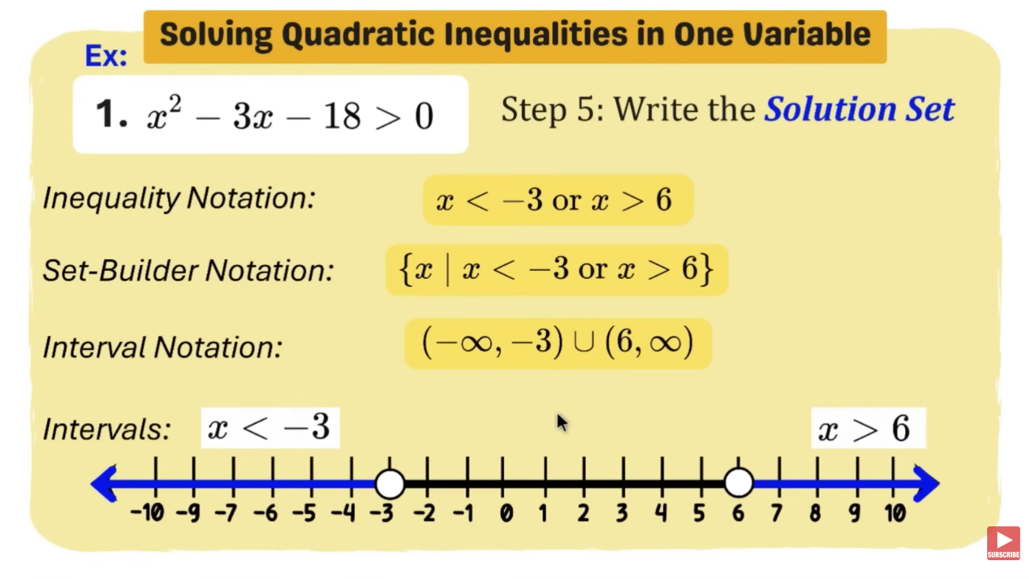

Example 2:
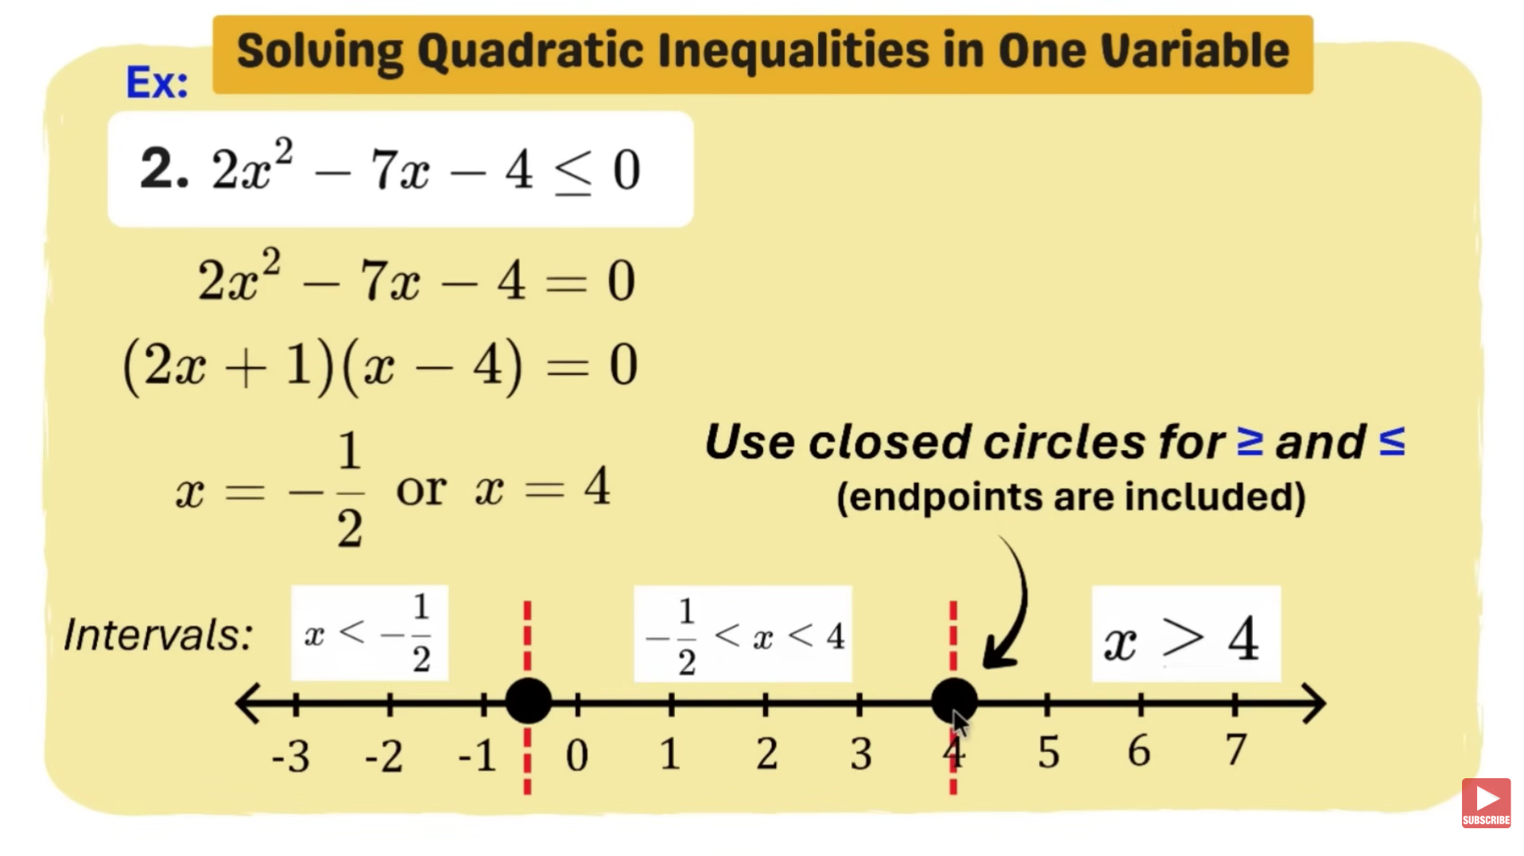 | 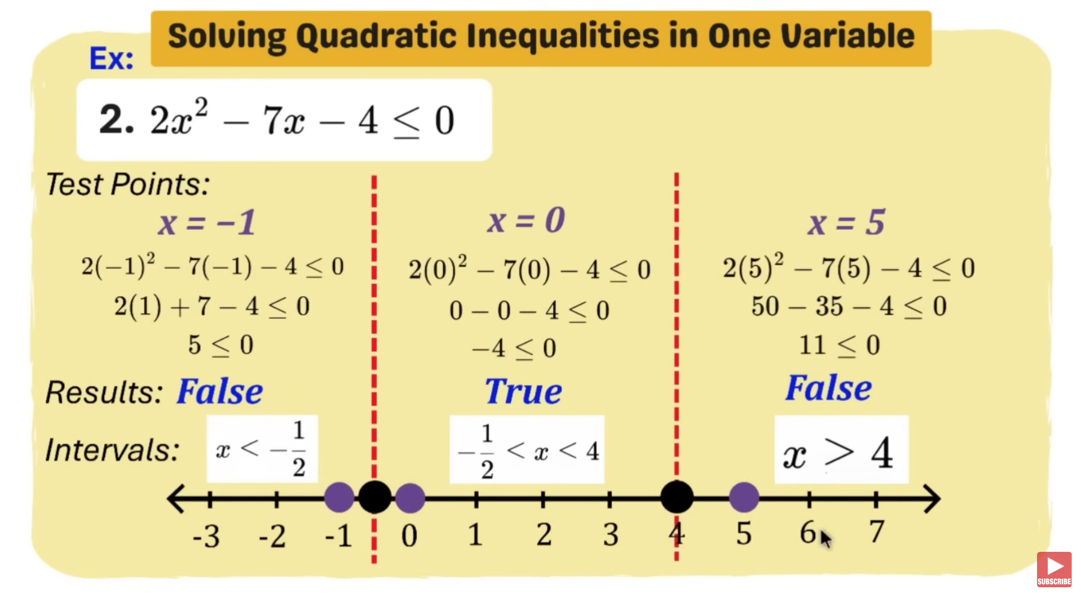
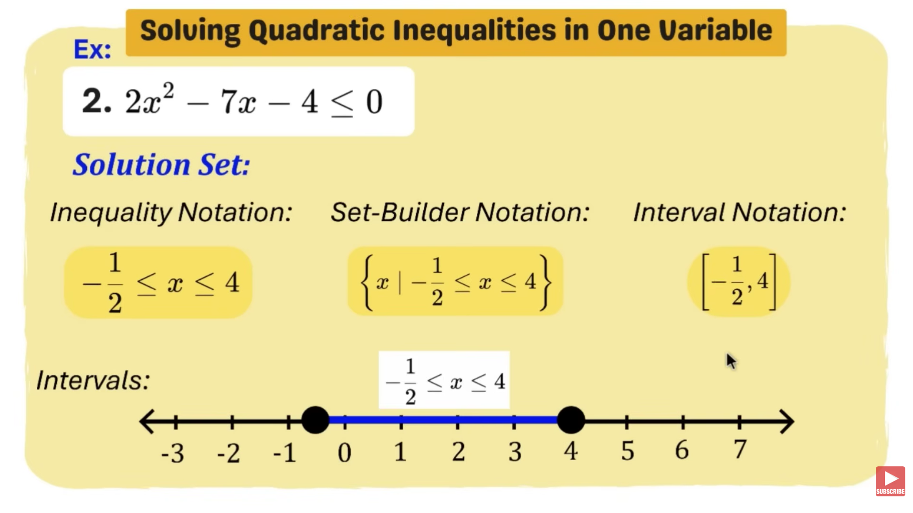

Example 3:
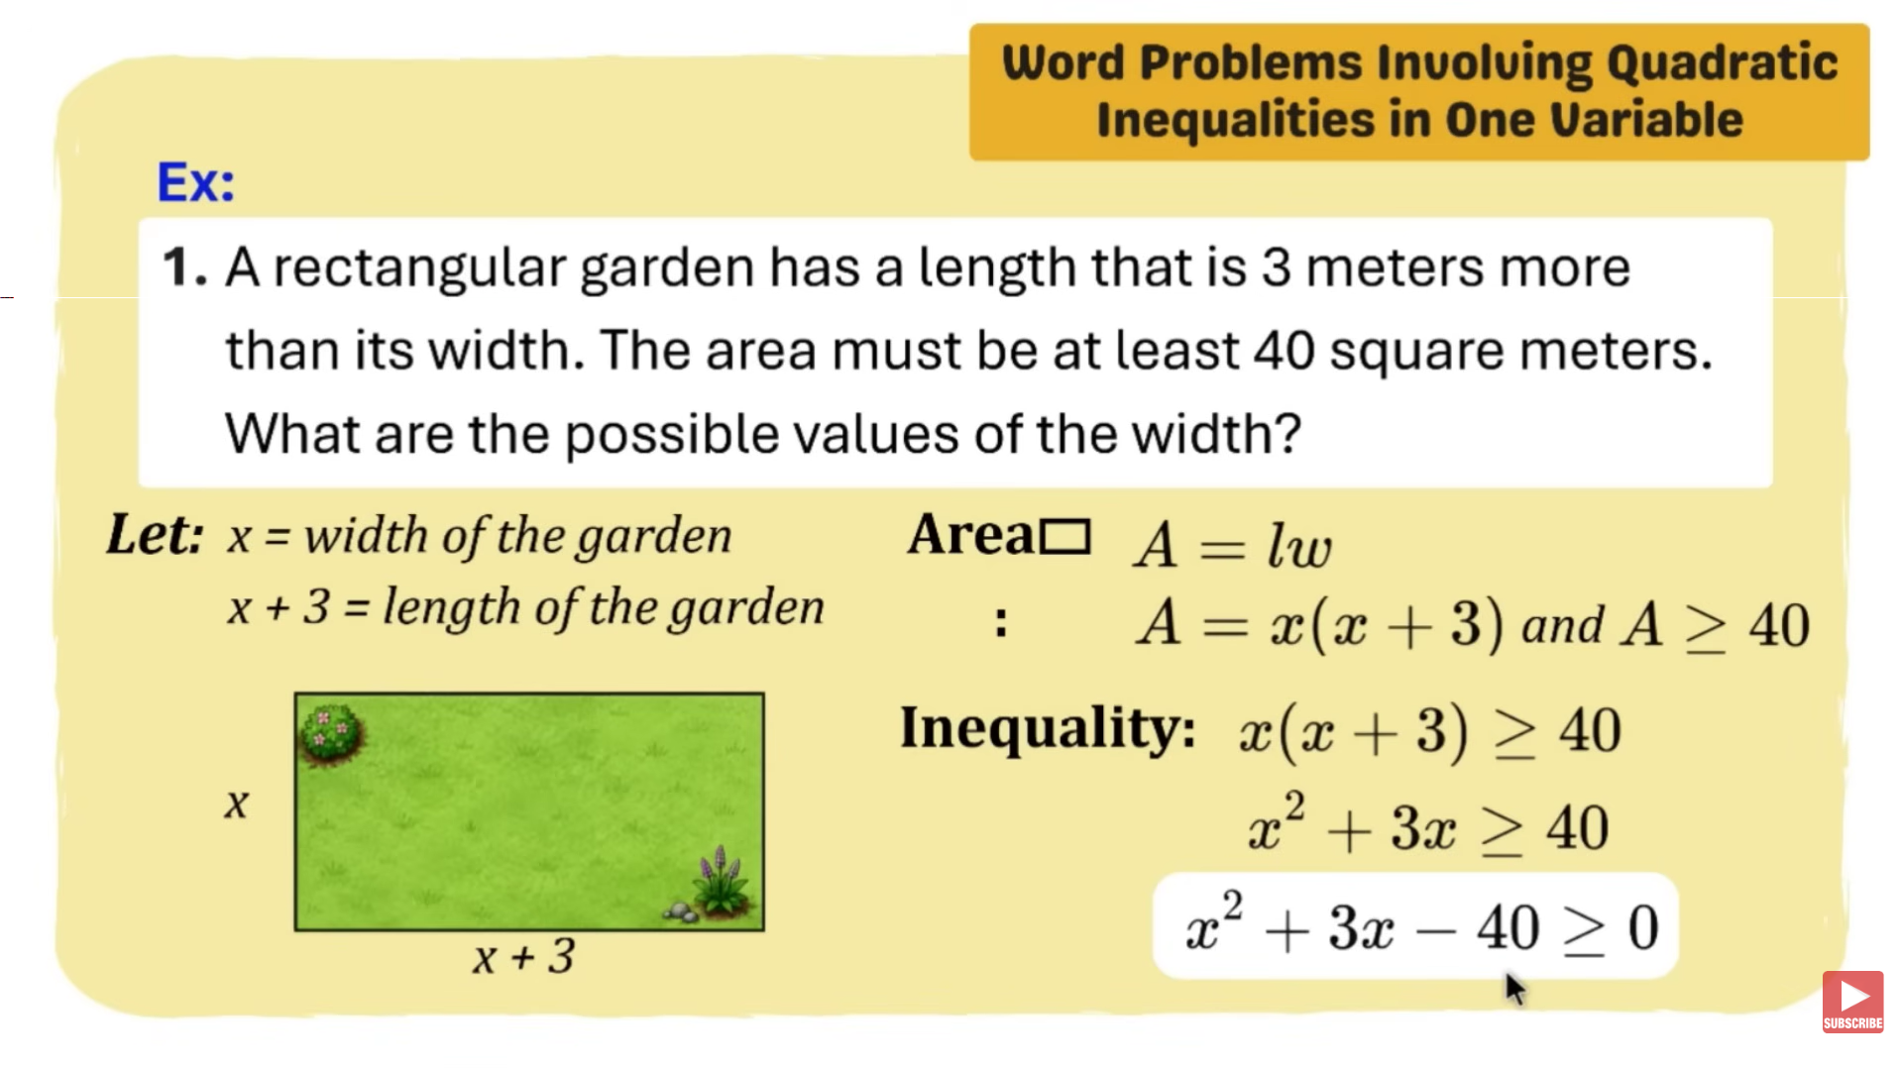 | 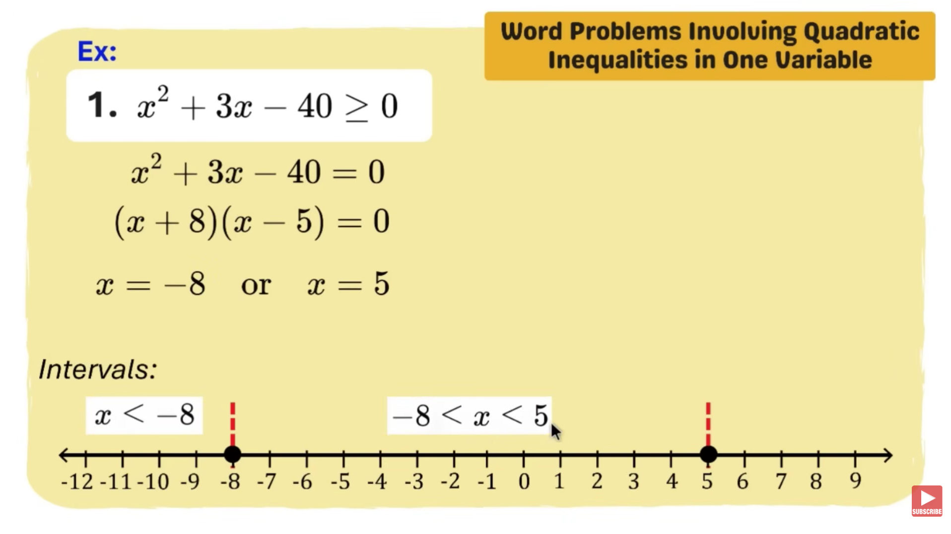
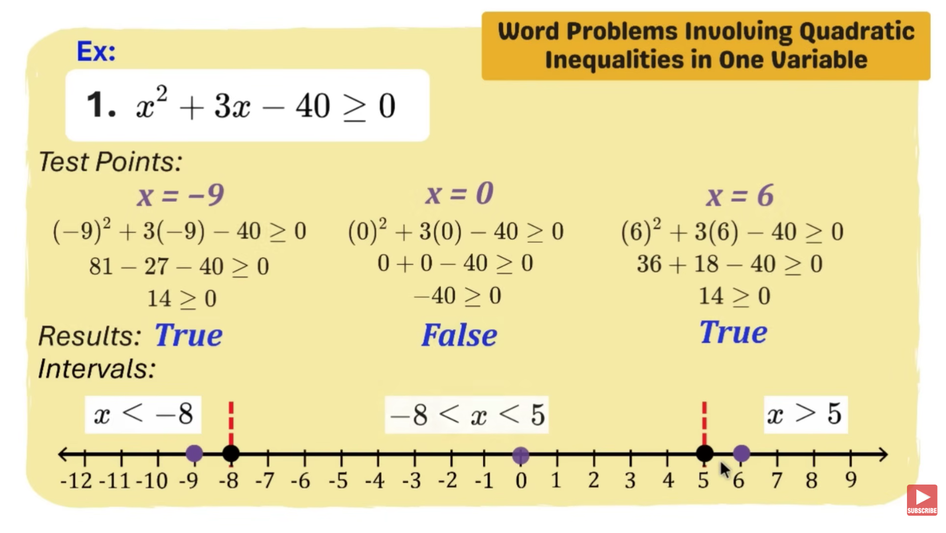 | 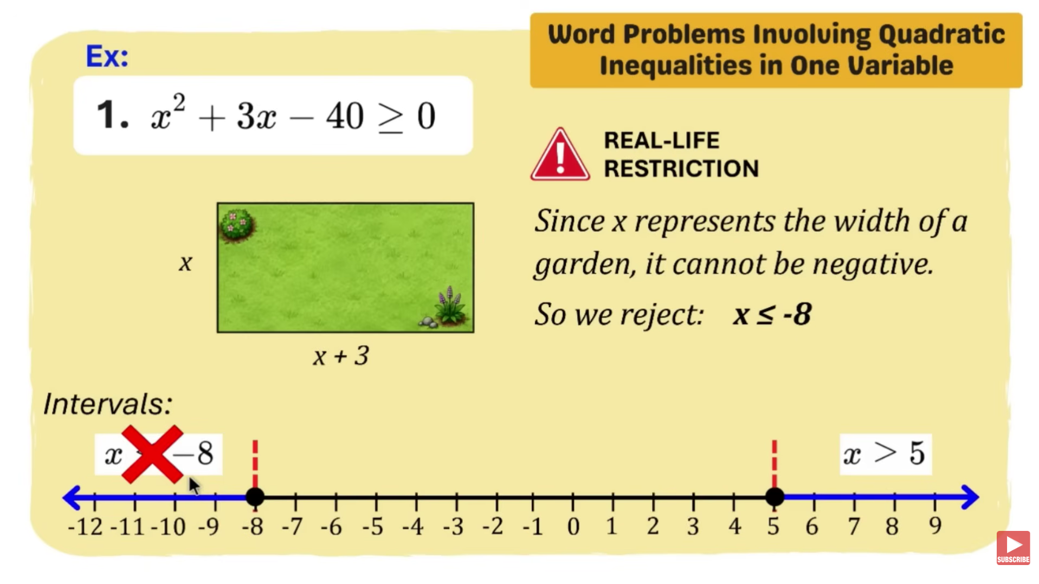
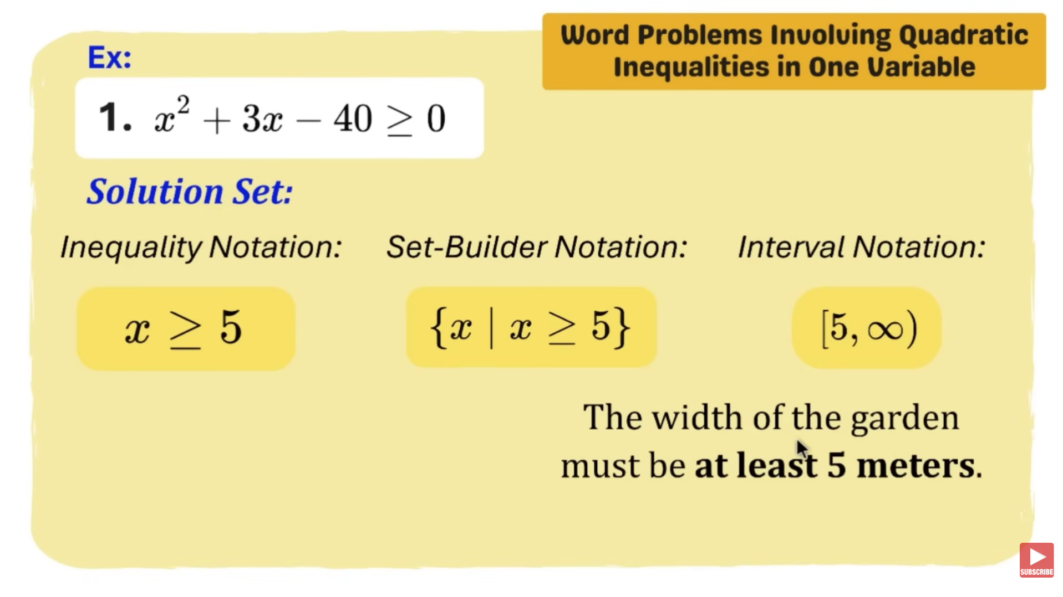 | 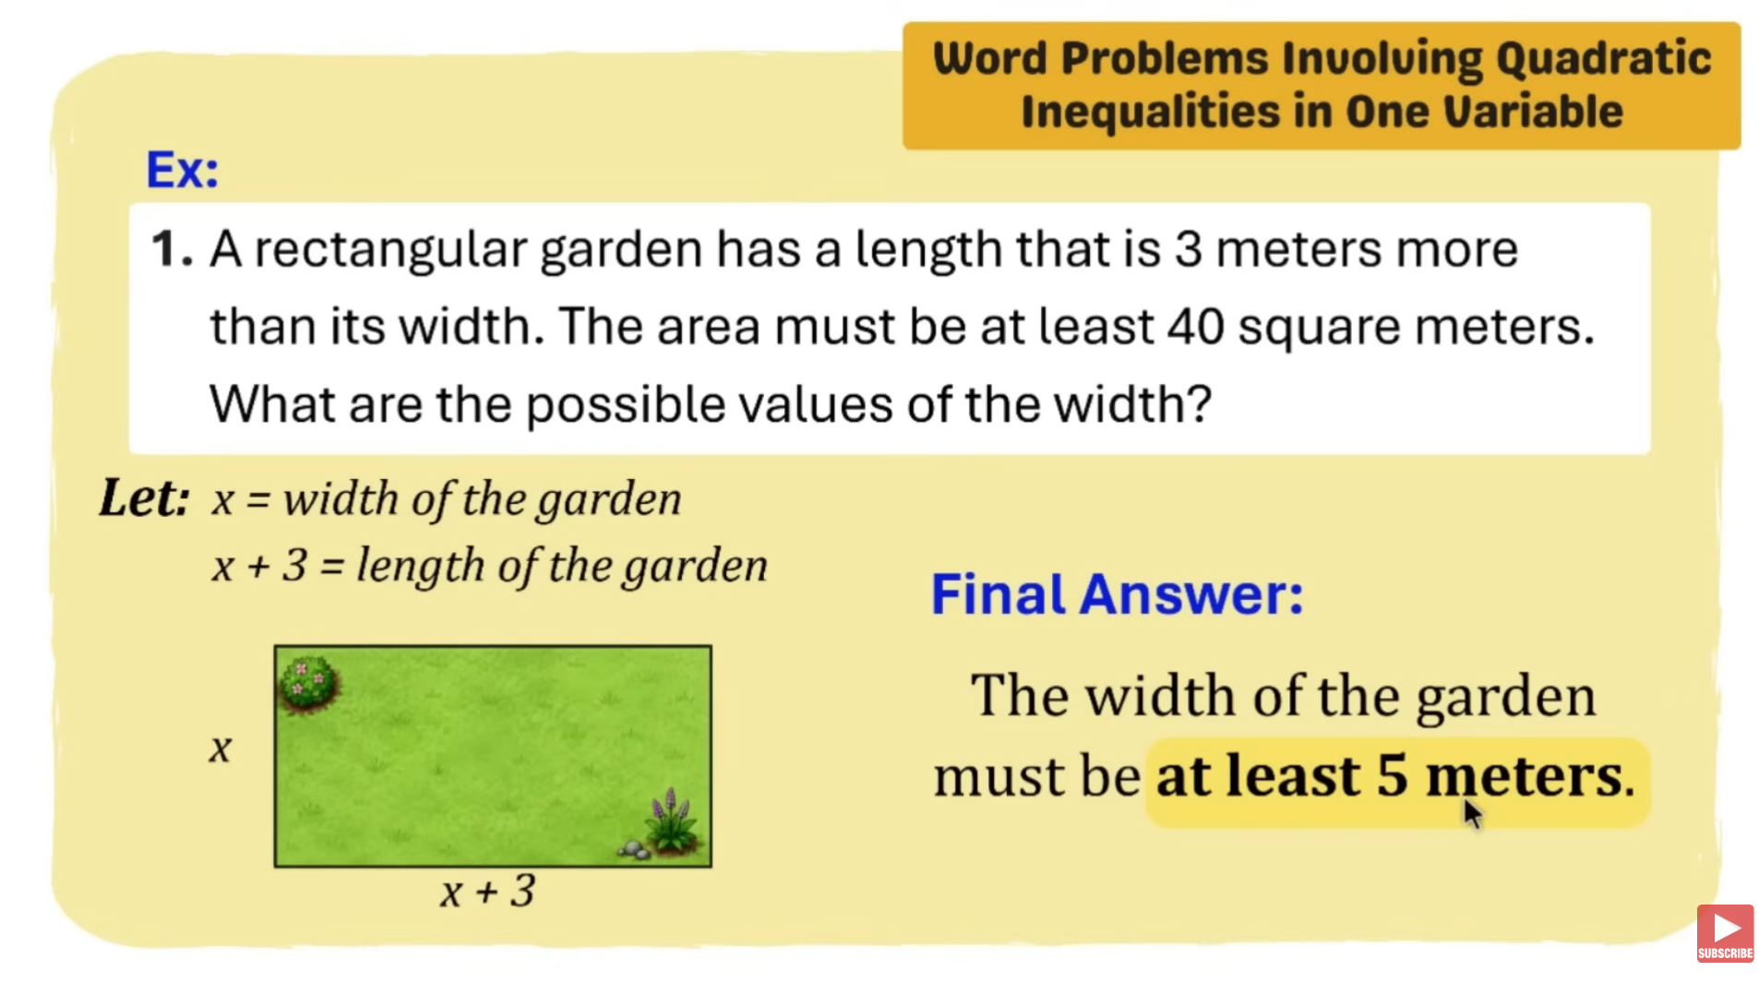

Example 4:
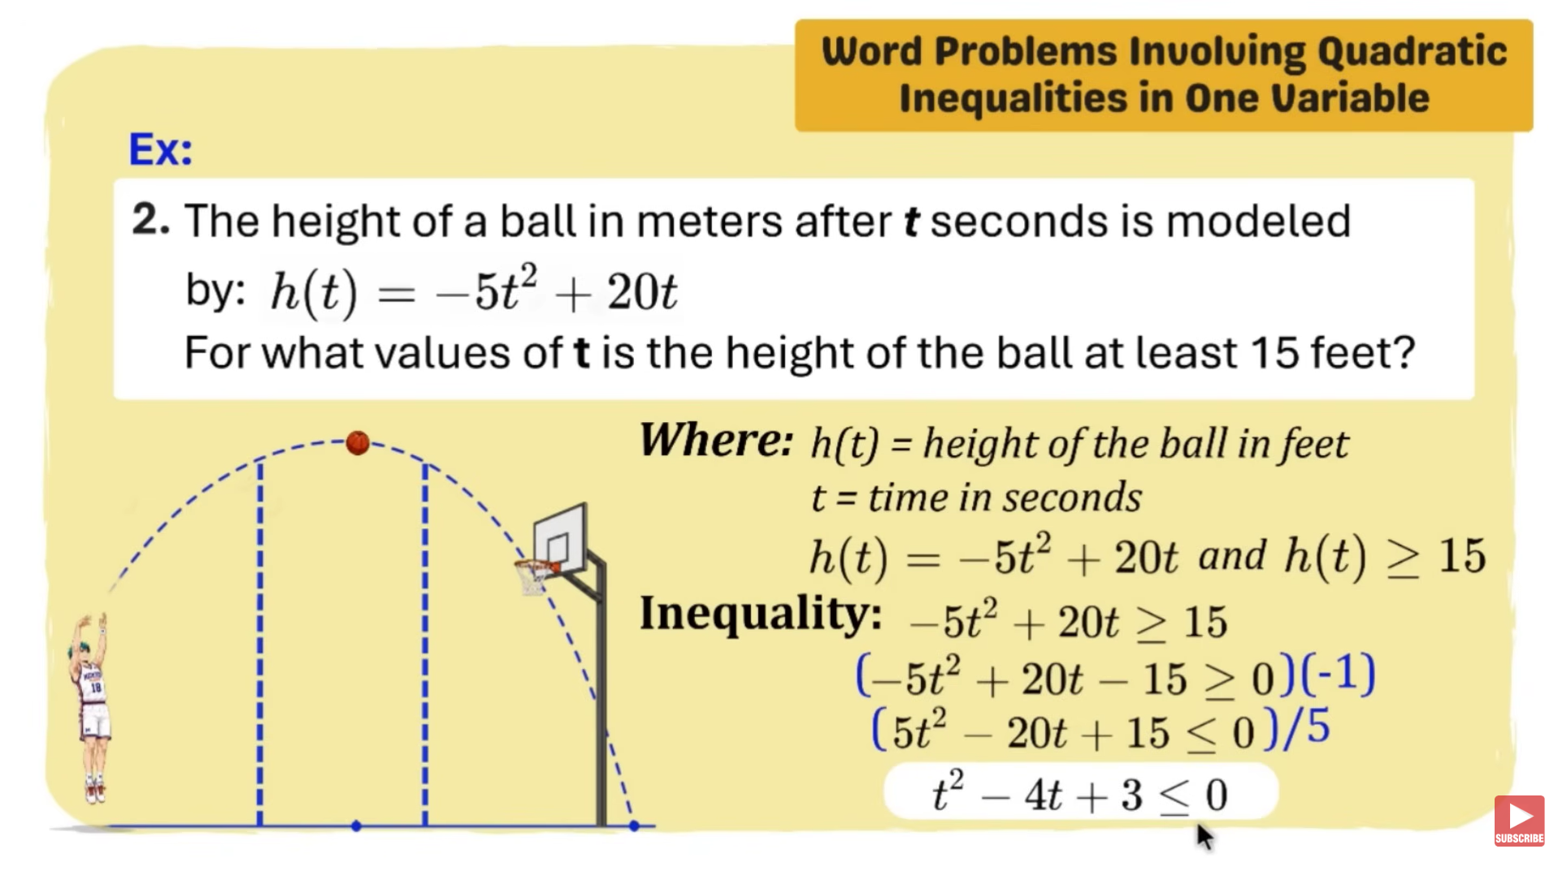 | 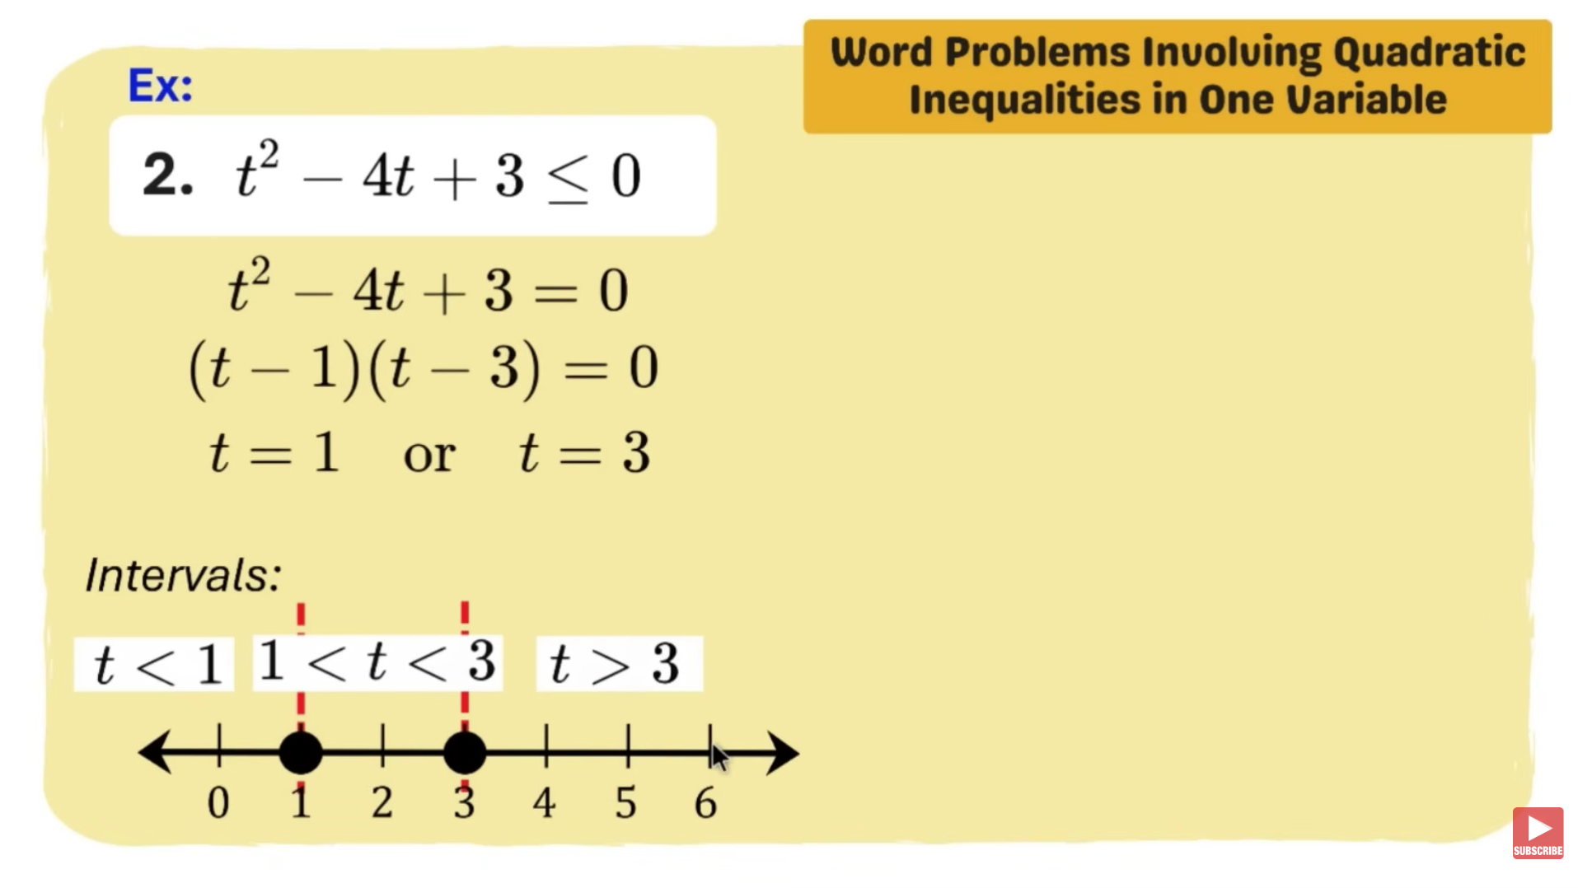
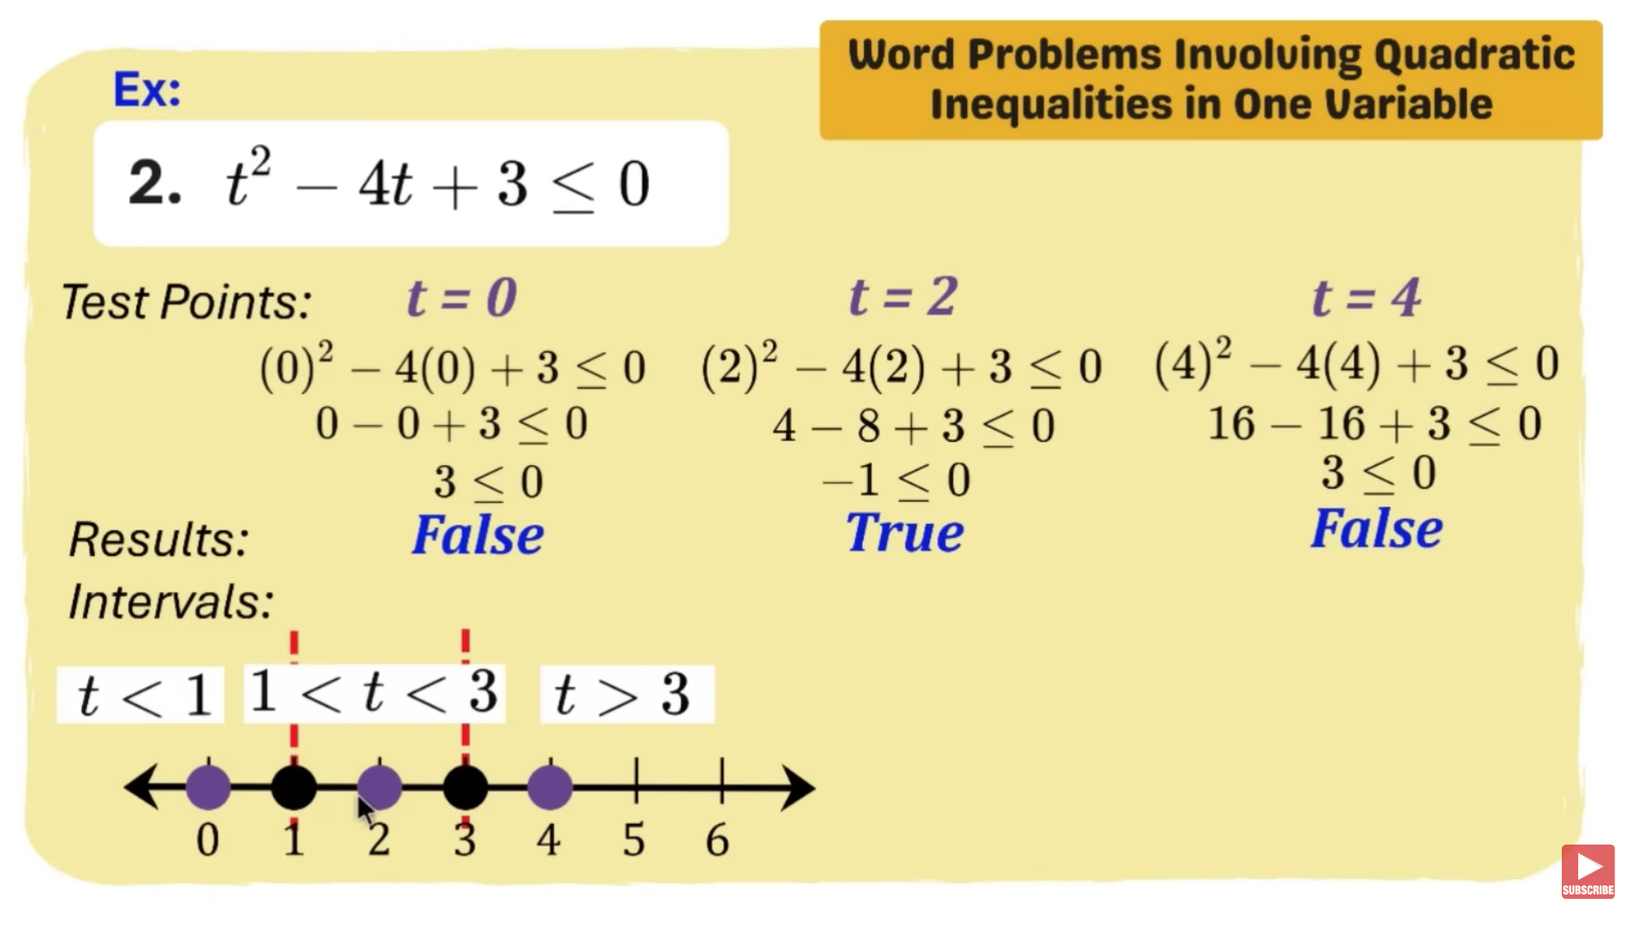 | 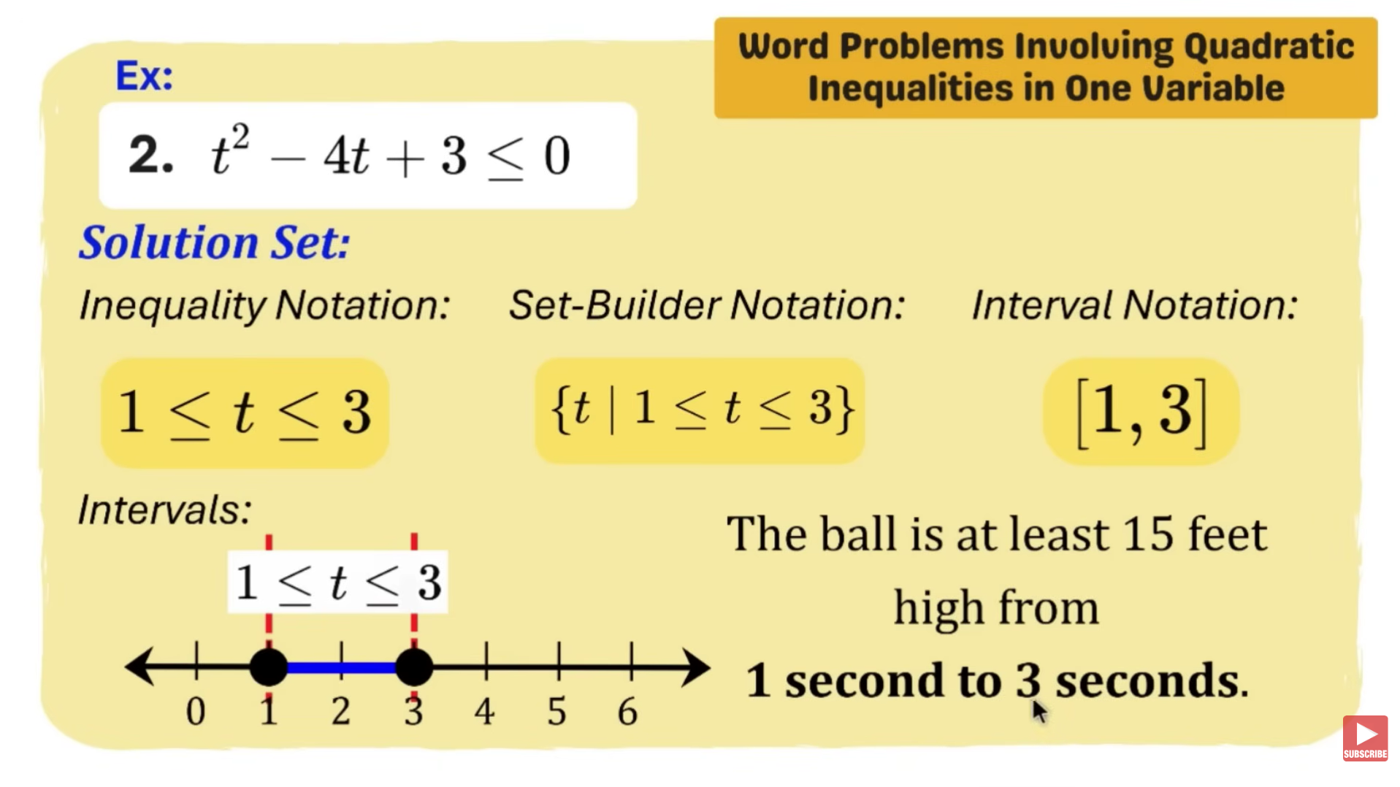

Step by Step Instructions:
- Step 1: Choose an ordered pair (x, y)
- Step 2: Substitute the values of x and y into the inequality.
- Step 3: Check if the statement is true.
Example 1: $2x+3y≤10$
- Step 1: Choose an ordered pair (x, y)
- The ordered pair is going to be (2, 1).
- There are still many ordered pairs that can either satisfy $2x+3y≥10$.
- Step 2: Substitute the values of x and y into the inequality.
- The result becomes x is going to be 2, and the y is going to be 1.
- Step 3: Calculate
- $=2\left(2\right)+3\left(1\right)≤10$
- $=4+3≤10$
- $=7≤10$
- Step 4: Check if the statement is true.
- Since the finished product states that 7 is lesser than or equal to 10. The equation is true and satisfies the inequality. Therefore, it will be a half plane (a line with a shaded region in a graph where if satisfied, it hits the origin).

